**IIT Indore Security Website Interactivity Project**

Project Designs

Version 0.1

February 06, 2015



Amey Ambade

Mudit Maheshwari

Avnish Bhagwate

Abhay Chandra

Contextual Model 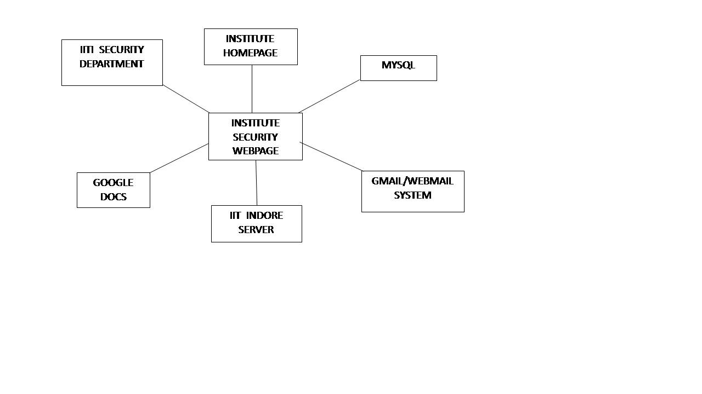

Behavorial Model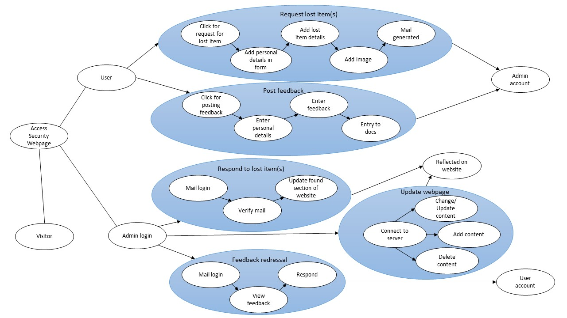

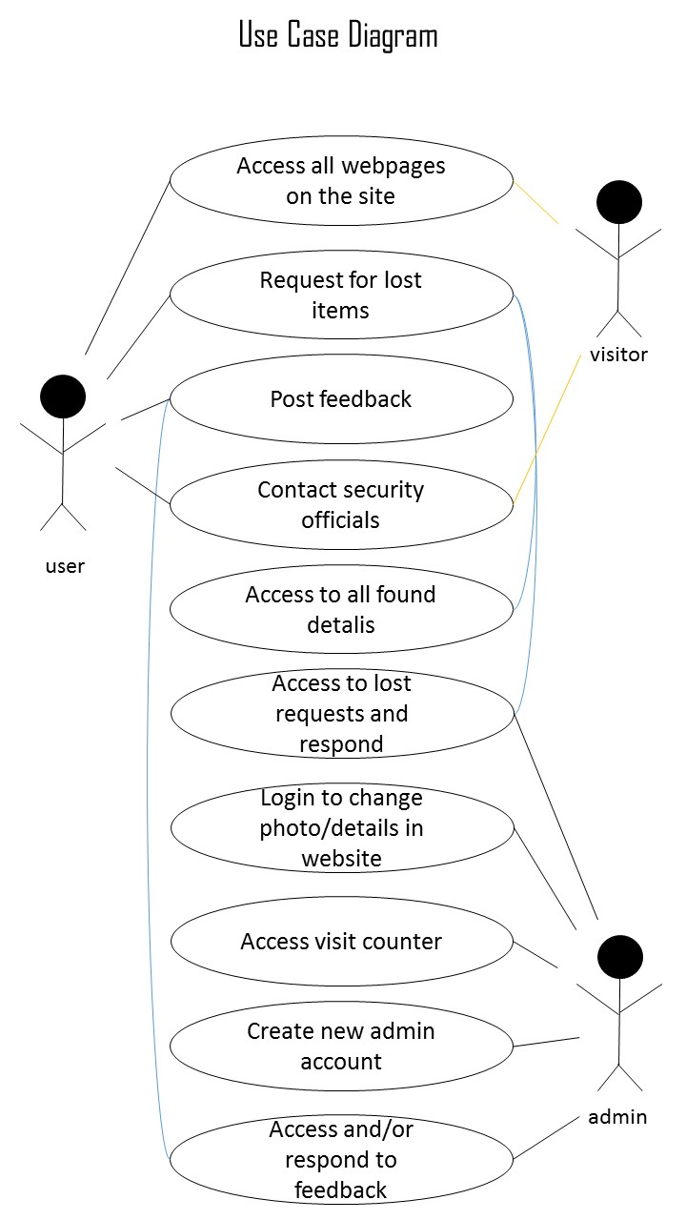Class D

Class Diagram

